Ex 9

Aim
To create an interactive web-based form that validates user input (Email and Phone Number) in real-time before submission, ensuring data integrity and providing immediate user feedback.
Procedure
The development was carried out in four distinct phases:
- Structure (HTML):
  - Developed an index.html file containing a form with unique IDs (email, phone).
  - Included empty <span> tags with the class error to serve as placeholders for dynamic error messages.
  - Linked the Validator.js CDN and a custom script.js file.
- Styling (CSS):
  - Used Flexbox in style.css to center the form on the screen.
  - Styled the form container with a white background, padding, and a subtle box shadow for a modern look.
  - Defined an .error class to display validation messages in red with a smaller font size.
- Logic (JavaScript):
  - Used document.getElementById to capture form and input elements.
  - Added a submit event listener that uses e.preventDefault() to stop the page from refreshing on submission.
  - Utilized the validator.isEmail() and validator.isMobilePhone(phone, 'en-IN') methods to check the validity of the inputs.
- User Feedback:
  - Implemented conditional logic: if inputs are invalid, the corresponding error message is injected into the DOM.
  - If valid, a success alert is triggered, and the data is logged to the console.

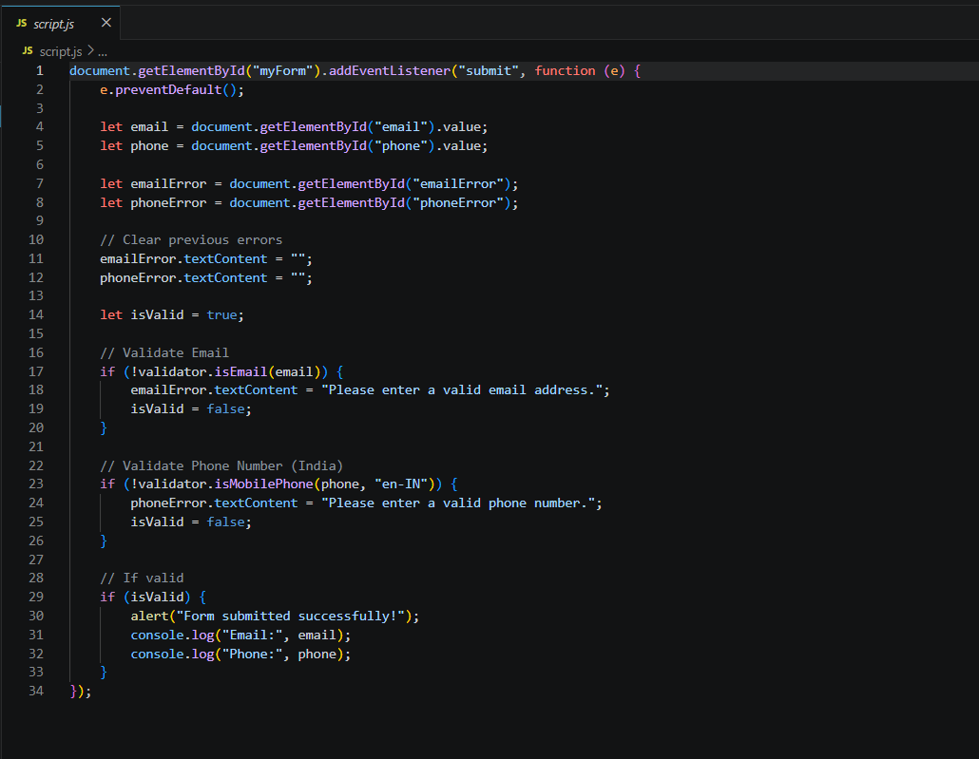

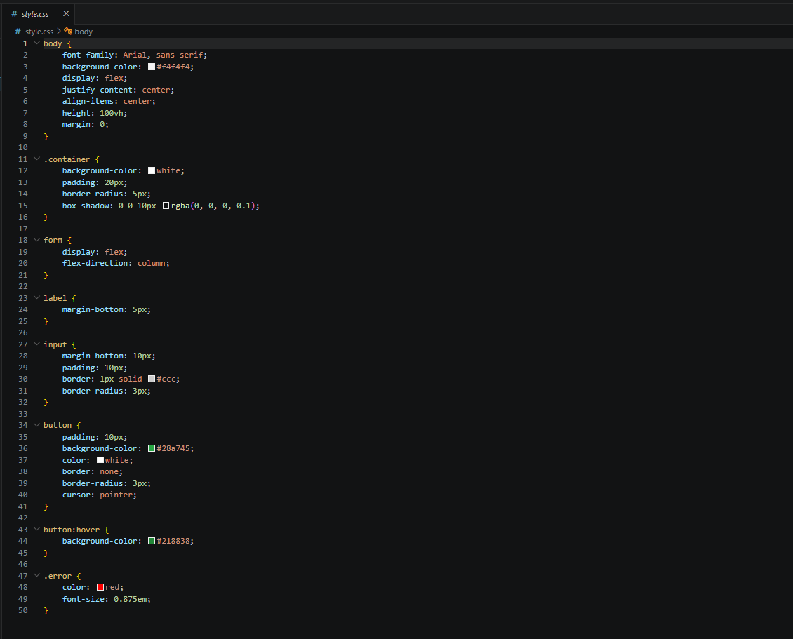
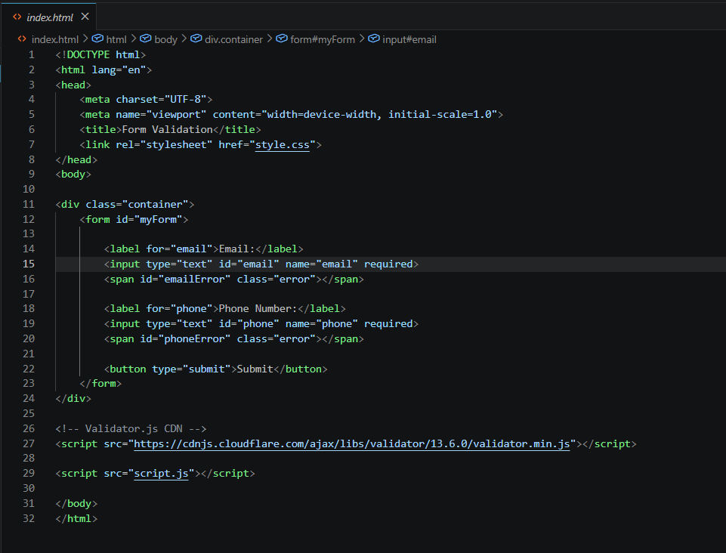

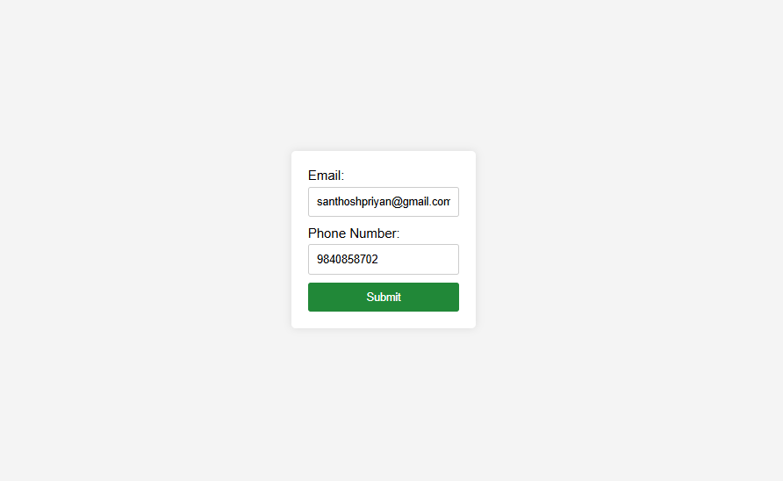

Results
The implementation successfully validates the form inputs based on the following criteria:
- Email Validation: Successfully identifies incorrect email formats (e.g., missing "@" or domain).
- Phone Validation: Specifically validates Indian phone numbers using the en-IN locale.
- Visual Feedback: The UI updates dynamically to show red error text when validation fails and clears previous errors upon re-submission.
- Final Output: As shown in the UI screenshot, a correctly filled form allows for successful "submission" simulated via a browser alert.

